SDG Scholarship
Applicant’s Information Kit
At Elemental Projects, we believe that every organisation has a moral duty to do what they can to support the transition to a fair, sustainable, better world. The UN’s 17 Sustainable Development Goals (SDGs) provide a unifying framework for this global effort. Our contribution is the SDG Scholarship.
Valued at $20,000, the SDG Scholarship includes fully funded training for the project manager and up to four of their team, and production of a short video documentary about the project.
We specialise in developing project managers working on any type of project and have delivered award-winning courses to thousands of project and program managers from across industry. Our core business is training ‘accidental project managers’ – technical experts delivering:
- Environmental projects: climate change research, habitat restoration, recycling, renewable energy
- Indigenous programs: land management, health, education, community services
- Social outcomes: marriage equality, gender equality, anti-corruption, anti-racism, justice
If your project supports one or more of the SDGs, be it Renewable Energy (Goal 7), Reduced Inequalities (Goal 10), or Climate Action (Goal 13), then we invite you to apply for the SDG Scholarship.
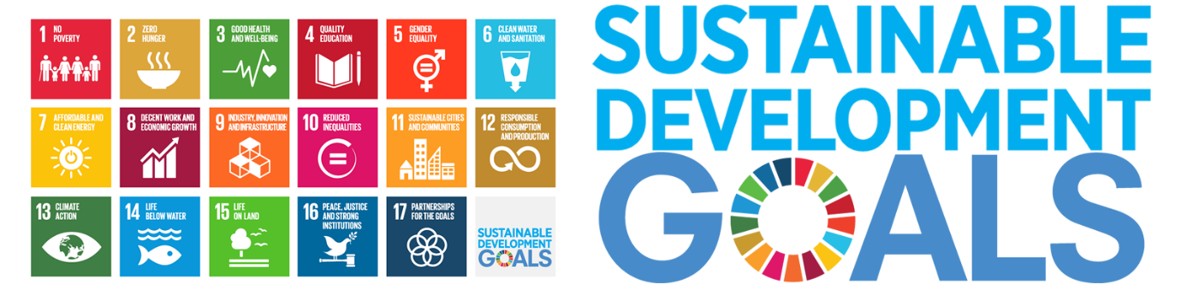
About the scholarship
The SDG Scholarship seeks to maximise the efficiency and impact of a wide range of SDG-aligned projects. Funding from industry sponsors goes entirely toward training, supporting, and promoting scholarship recipients and their project.
Applications are evaluated by the UNGC Australia Network to determine the project with the strongest alignment to the Goals. Elemental Projects then awards the Scholarship to the recommended project.
The recipient and up to four team members attend 12 half-day training sessions (online or in-person) delivered as part of a public Diploma of Project Management course. During training, the SDG Scholarship team will use in-class activities to workshop the project management deliverables for their project. Outside these training sessions, ongoing learning is supported through structured peer-coaching and complementary access to Ecademy – our on-demand video-based learning platform – for the entire delivery team.

Approximately one year after training, we produce a short documentary video about the project, how it was implemented, challenges overcome, and lessons learned. This may be posted in social media, websites, and other promotional channels to raise awareness of their organisation and the cause that the project supports.
The SDG Scholarship is our contribution to the cause. We’d love to hear about yours.

SDG Scholarship
Application Form
To apply for the SDG Scholarship, please complete this form and send to info@elemental-projects.com.au.
Applicant Details
Name: |  | Phone:
Organisation: |  | Title:
Email:
Project Details
Project Name: |  | Budget:
Start date: |  | Duration:
What is the project about?
Enter response here…
What is the background and planned outcomes/benefits of the project?
Enter response here…
How does the project align with the UN Sustainable Development Goals?
Enter response here…
What difference would this scholarship make in terms of your ability to successfully implement the project?
Enter response here…
Applicant’s Declaration
By signing below, I acknowledge that the details that I have provided are true and accurate to the best of my knowledge. If the project described above is awarded the SDG Scholarship, then on behalf of the performing organisation, I acknowledge and agree to the following:
- The project has internal approval including at least preliminary budget approval.
- The project manager and up to four team members have approval to attend all training sessions.
- Elemental Projects is authorised to use the organisation’s name and logo to:
  - Promote the project and its award of the SDG Scholarship via social media, website, and other media.
  - Produce a 3-5 minute mini-documentary video about the project, referencing the SDG Scholarship, and acknowledging industry sponsors at the end.
- Should the project be cancelled or undergo a change in scope that changes its alignment with the SDGs, the mini-documentary video will not be produced, however the team may continue to attend training.
- The Scholarship excludes travel and accommodation expenses associated with attending training sessions in Sydney, as well as personal coaching sessions, and award of the Diploma of Project Management.
Signature: |  | Date:

